# NETWORKING & SYSTEM ADMINISTRATION LAB

**Name: LIBIYA JOSE**

**Roll No: 14**

**Batch: MCA B Date: 04-04-2022**

**Experiment No.: 5**

# Aim

Familiarization of basic Linux commands.

# Procedure

1. **cp**

This commands in Linux allows you to copy a file or an entire directory to another Directory specified.

**Syntax:-** $ cp file_to_be_copied directory_name

# Output:-

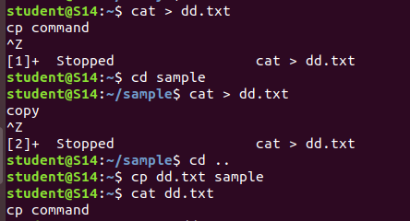

1. **cp –r**

This command in Linux allow us to copy an entire directory into another directory

**Syntax:-** $ cp –r source_directory destination_directory

# Output:-

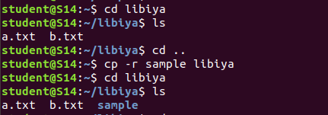

1. **cp - i**

This command helps to make a decision regarding overwrite that may happen in case of copying a same named file (but different in content) from the source folder to the destination folder.

**Syntax:-** $ cp - i filename destination_folder

# Output:-

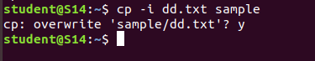

1. **mv**

This command will move a specific file or directory to another directory **Syntax:-** $ mv file_name/directory_name destination_directory **Output:-**

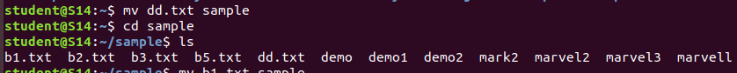

# mv -i

This command enables a dialog to take a wise decision about overwrite in case of moving A file with the same name as that of one already exist in the destination directory.

**Syntax:-** $ mv - i filename destination_path

# Output:-

